**SKILL BASED ONE-DAY WORKSHOP**

**on**

“**MAKE A CRAFT WITH INNOVATIVE CRAFT**”

**Date:** 17.12.2019 **Venue:** Nagarathinam Angalammal Arts &

Science College, Madurai

Women’s Studies Centre of Madurai kamaraj University, Madurai in collaboration with Nagarathinam Angallamal Arts and Science College and Kokuyo Camlin limited organized a One-Day Workshop on “Make a Craft with Innovative Art.” Hundred and twenty five (125) participants were benefitted by the Workshop. The Workshop was started with the Welcome Address by Dr.R.Radhika Devi, Director i/c of Women’s Studies Centre. In her Welcome Address, she pointed that learning to make a craft with beautiful art makes the mind livelier and increases concentration. The students get trained in making a nice art can sell it. The workshop was continued by the experts from Camlin limited.

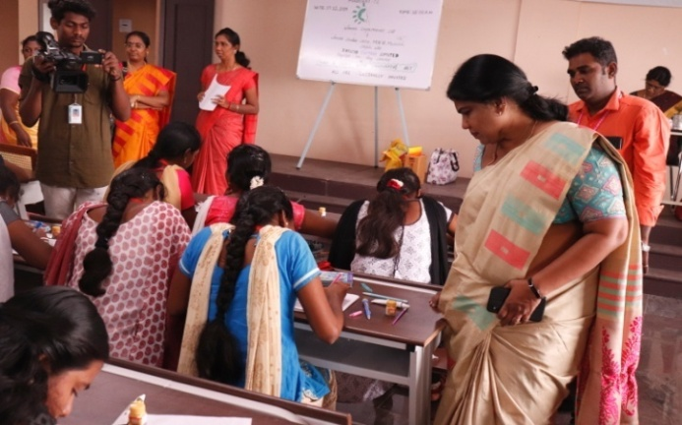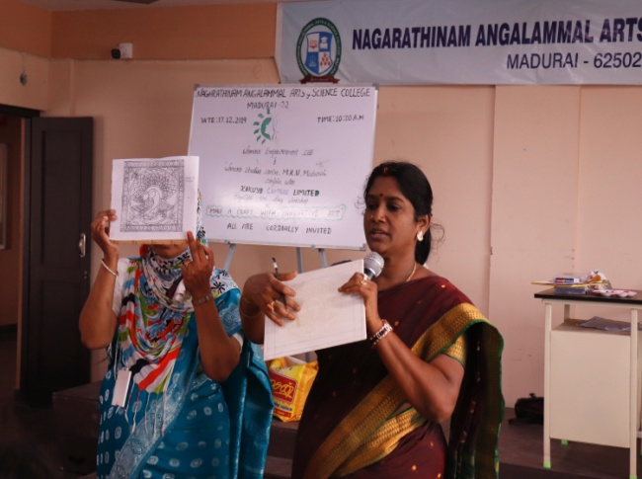

The participants were given a painting kit which includes acrylic colour painting boxes, painting brushes, tracing sheets and a painting board. The experts first explained the advantage of using boards for painting, in a hard board; the surface is more rigid, so there tends to be less cracking in the painting as it dries quickly. Further they explained that the experience of painting on hardboard is distinctly different than that of painting on canvas, and many painters prefer this. The surface is quite smooth, and the paint glides onto the surface and is easy to move around. They told the students to start with few acrylic colours until they get the feel of the paint before adding the complexity of color. The acrylic paints are easy to paint and best for beginners to paint as it would not easily to roll down like other paints. The students were asked first to trace the drawing given in the tracing sheet with a pencil.

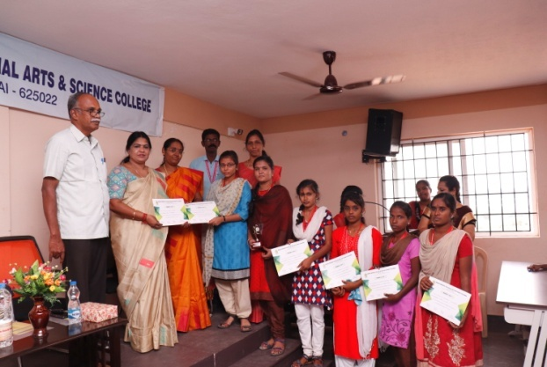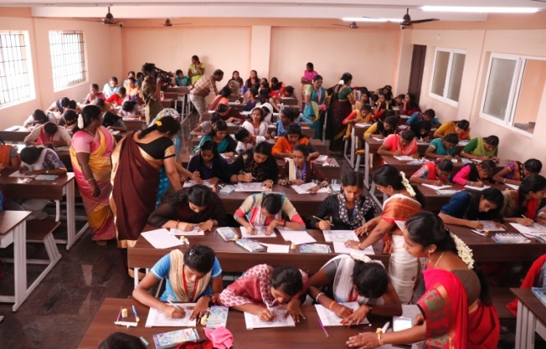

After tracing the drawing from the tracing sheet, the students were asked to start to paint the outline with an outline acrylic paint which was white in colour. The students were advised to give the outline slowly so that the paint would not go away from the outline. The students were asked to allow the outline to dry for 15 to 20 minutes After the first coat has dried, take the desired colour and draw the ouline with the colour. The students were suggested that if they want a slower drying time they can add a retarding medium to the paint, for thicker paint, add a gel. The students were told the reason of why they are using acrylics the reason is listed below

* For easy cleanup time.
* Painting on a limited budget.
* To enjoy experimenting with mixed media.
* Sensitive to the harsh chemicals involved with oil painting.

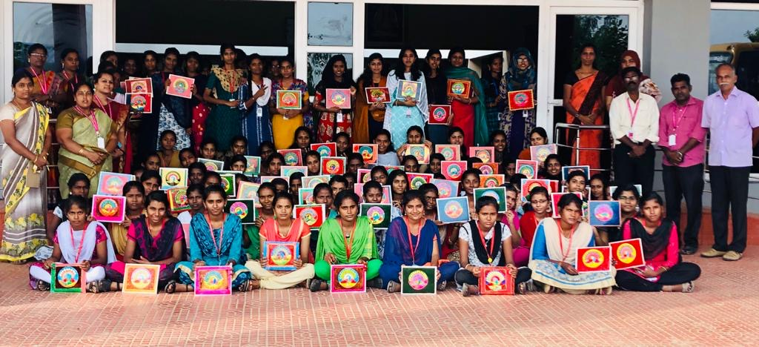

Finally the students were asked to follow the same step giving outline and allow them to dry and finish the drawing. The students were advised that slight dip of brush into the water gives a nice painting. For better result the students were advised to draw the painting roughly in a paper. The workshop ended with a discussion and feedback session. The participants said they have benefited by the workshop on learning the techniques.

**ONE-DAY INTERNATIONAL CONFERENCE**

**on**

**Women Empowerment through Entrepreneurship: Opportunities & Challenges**

**Date:** 06.03.2020 **Venue:** Malligai Arangu,

NAAS College, Madurai

Women’s Studies Centre of Madurai Kamaraj University organized an One-day International Conference on “**Women Empowerment through Entrepreneurship: Opportunities and Challenges**” in connection with the International Women’s day 2020 in Collaboration with Department of Commerce, Nagarathinam Angallammal Arts and Science College. Around **350 participants** participated in the conference. The conference began with a Welcome address by Thiru N.Jegatheesan, Secretary NAAS College, Madurai. In his welcome address, he stressed the importance of the conference by saying that entrepreneurship has the ability to improve standards of living and create wealth. Especially Women Entrepreneurs make every effort with innovation, where new and improved products enable new markets to be developed. Women are achieving in all sectors, from Vehicle driving to working in the Space Station.

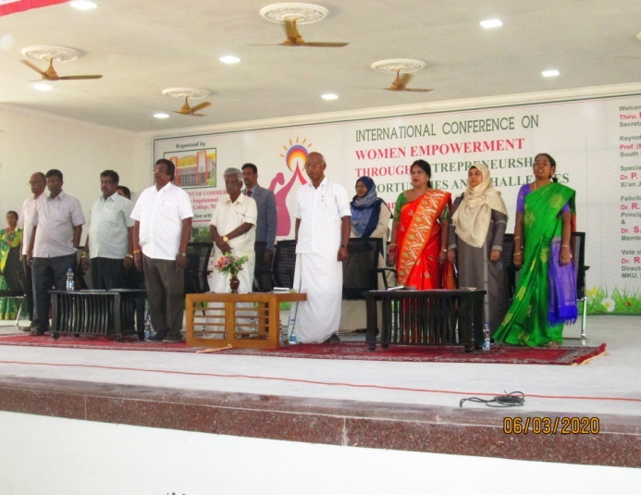

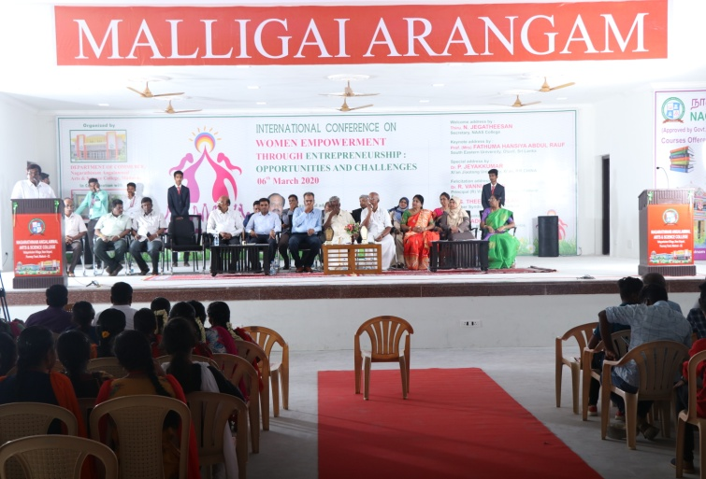

He also pointed out that Women are taking leadership responsibilities. At present, there are three Supreme Court judges in India and in the sports field; women like Marykom bring laurels to our country. Flight Lieutenant Avani Chaturvedi (born 27 October 1993) is an Indian pilot from Rewa District, Madhya Pradesh. She was declared as the first Combat Pilot along with two of her cohorts, Mohana Singh Jitarwal, and Bhawana Kanth. The trio was inducted into the Indian Air Force fighter squadron in June 2016. He further said that women know techniques to convert the latent and idle resources like land, labour and capital into national income and wealth in the form of goods and services. They help to increase Net National Product and Per Capita Income in the country. Women should have positive attitude that we can achieve still more. He concluded by saying that the conference will bring more ideas on Empowering Women through Entrepreneurship.

Inaugural address was delivered by Dr. S.Theenathayalan, Member Syndicate, Madurai Kamaraj University, Madurai. In his Inaugural address, he said that one has to have passion and desire to achieve things. It is not possible to have success with in a day. He stated that Indian Government under the leadership of Hon’ble Prime Minister Narendra Modiji give more importance to entrepreneurship and develop them through Entrepreneurship programmes like Startup Schemes for Entrepreneurs. Women Entrepreneurs are facing problems as they have to play dual role. Today production is easy but marketing is difficult. The world Economy is declining for which everyone must come forward. In all aspects of life there are challenges. Challenges and opportunities are both side of a coin.

He further said that women have skills to find solutions for any sort of tribulations. Encouraging more Women as Entrepreneurs will develop a Nation. Today women are like to be members of a group but many are not ready to lead a group and bring changes in the society. Due to lack of awareness, many women are unable to utilize the opportunities. The world economy is declining for which everyone must come forward to improve the economy. We must be here to find out the solutions and this can be done with the help of women.

He finally concluded by saying that entrepreneurs are within us and we have to bring out the skills to become an Entrepreneur. Women have to develop Entrepreneurship Skills and undergo the training programmes to overcome the challenges faced by women. He also stated that there are more Government Schemes for Women Entrepreneurs but takers are very minimal. It is high time to take hold of opportunities around us. We can create opportunities for others if we learn the entrepreneurship skills. Women should gather knowledge on Entrepreneurship by attending more Conferences and Workshops on Entrepreneurship Skills.

Prof. (Mrs) Fathuma Hansya Abdul Rauf, South Eastern University, Oluvil, Sri Lanka delivered the Keynote Address. In her address, she stated about the condition of women in Sri-Lanka. The Democratic Socialist Republic of Sri Lanka is composed of two major ethnic groups, the Sinhalese and the Tamils. The Sinhalese, who form the majority of the country's population are concentrated primarily in the central and southwestern parts of the country and to a lesser degree in the Eastern Province, while most Tamils live in the Northern and Eastern Province. Women in Sri Lanka are not a homogeneous group and their lives, status and decision-making ability differ according to class, ethnicity, culture, religion, caste and geographical location.

Moreover, Sri Lanka is considered to be one of the most progressive country compared to other South Asian Countries. Sri Lankan women have higher literacy rates, lower maternal and child mortality rates, and an average life expectancy of 67 years. Despite these advantages however, most Sri Lankan women occupy positions of limited influence in the Social, Political and in the Economic sectors. She further said that the Sri Lankan women are most affected by the civil war. There has been only a marginal increase in enrolment of women in Higher Education. As economic producers, women have been traditionally active in the labor force although labor force participation rates underestimate their participation particularly in home-based activities. The quality of employment available to women has also deteriorated. Women have tended to be pushed out of stable employment in the formal sector to marginal economic activities and to unviable self-employment. Due to this few, women are entering to new areas of employment. The majority of women are concentrated in domestic and plantation agriculture, traditional local industries, assembly-line industries in the modern sector.

She also said that Women, however, tend to be seen as farmers’ wives rather than as economic producers. In fisheries, modernization has affected women’s traditional activities such as fish processing and net repair. Women have access to employment opportunities only in the semi-skilled labor-intensive industries. Long working hours, exposure to occupational health hazards, vulnerability to job insecurity, inequitable gender division of labor, and gender subordination in the labor market are characteristic features of women’s work in Sri Lanka.

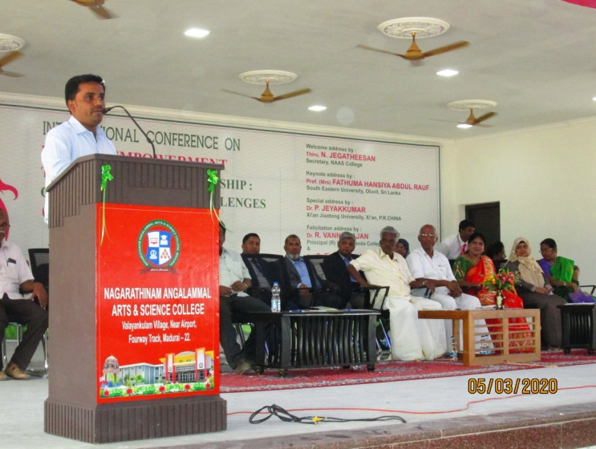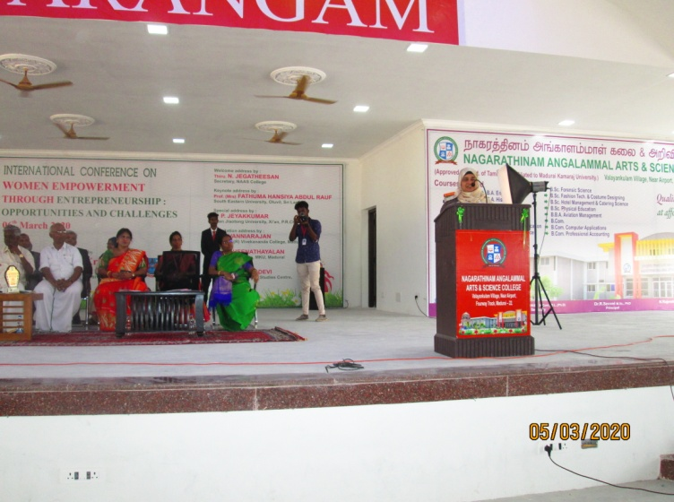She concluded that if more women are brought into formal sectors and trained by the Entrepreneurial programme, they would be empowered. Encouragement from all walks of life to women would be a great support for Women.

Dr. P. Jeyakumar, Xi’an Jiaotong University, Xi’an P.R.China delivered special address. In his address, he told about the life of Women Entrepreneur kiranMazumdar-Shaw whowas born on 23rd March 1953 in Pune, Maharashtra State. She was educated at Bangalore's Bishop Cotton Girl's High School, graduated in 1968. She then attended Mount Carmel Women’s College, Bangalore, Women's College for pre-university courses. He then stated that her father Rasendra Mazumdar, was the Head Brew Master at United Breweries. He suggested his daughter to study Fermentation Science, and train to be a Brew Master, a very non-traditional field for women.  Mazumdar went to [Ballarat College](https://en.wikipedia.org/w/index.php?title=Ballarat_College&action=edit&redlink=1" \o "Ballarat College (page does not exist)), Melbourne University in Australia to study Malting and Brewing. In 1974, she was the only woman enrolled in the Brewing Course and topped in her class. She earned the degree of master brewer in 1975. She worked as a trainee brewer in Carlton and United Breweries, Melbourne, Australia. When she investigated the possibility of advancing her career in Bangalore or Delhi, she was told that she could not be hired as a master brewer in India because "It's a man's work. Initially, she faced credibility challenges because of her youth, gender and her untested business model. Funding was a problem: no bank wanted to lend her money, and some required her father be a guarantor. A chance meeting with a banker at a social event finally enabled her to get her first financial backup. Now she is the chairperson and managing director of Biocon Limited, a biotechnology company based in Bangalore, Indiaand the former chairperson of Indian Institute of Management, Bangalore.

With her continuous efforts after overcoming challenges in 2014, she was awarded the Othmer Gold Medal for outstanding contributions to the progress of science and chemistry. She is on the *Financial Times*’ top 50 women in business list. In 2019, she is listed as the 65 most powerful woman in the world by *Forbes*. She again featured on the list - the most powerful women in the world - in 2016 and 2017 at 77th and 71st positions respectively. He concluded by saying that there are many examples like this. Today women can achieve many in spite of struggles or challenges around them if they have strong minds to achieve.

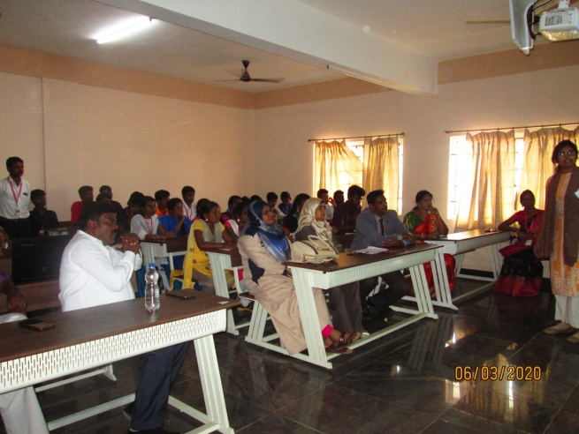

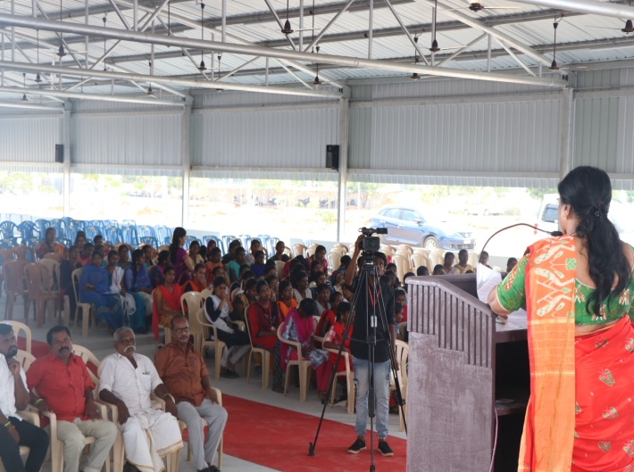

Dr.R.Vanniarajan, principal (R) Vivekanda College, Madurai delivered the felicitation address. In his address, he stressed about the importance of Indian Culture respecting women. We should learn from the Indian traditions that respect women. We should not see everything in life as a problem. Entrepreneurship empowers women. It makes women independent. Many women are backbone for our country’s freedom we must learn from them. He gave example of ‘Viking’ and ‘Anand’ are leading brands of Tirupur, the Hosiery Capital of the Country. These two brands can be credited with setting the ball rolling for the other brands which grew out of Tirupur. A vertically integrated group, Viking has expertise ranging from fiber to finished garments. The group is the brainchild of Mr. A.C. Eswaran, popularly referred to as ‘Viking’ Eswaran, under whose able leadership it has grown steadily over the years. Mr. Eswaran’s success story epitomizes the dynamic entrepreneurial spirit that this city is famed for. He said: “For 10 years I learnt the trade.” He made sure that he was well versed with every aspect – spinning, weaving, knitting, dyeing, marketing, etc. It is only after he became thorough with all such aspects that he decided to set up my own business. Anand Hosieries, which he started in a small way in 1964, was mainly into production of innerwear. Mr. Eswaran’s relentless pursuit and sheer hard work saw the company create a name for itself over the years. It is important that before becoming an entrepreneur learning thoroughly the skills of entrepreneur are needed. He concluded that each and every woman, whoever it may be have to pass through hard work, dedication, challenges and difficulties after crossing these things without backing up women can achieve things and become an entrepreneur.

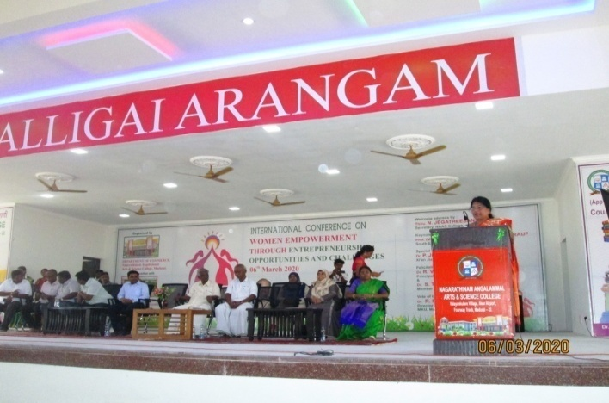 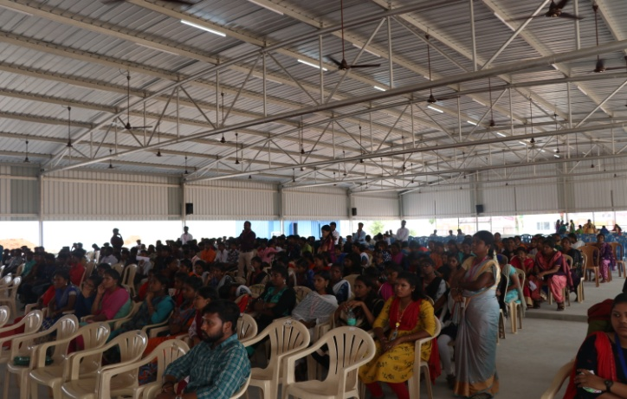

The conference ended with the Vote of Thanks by **Dr.R.Radhika Devi,** Director i/c , Women’s Studies Centre, Madurai Kamaraj University. In her speech, she thanked the Hon’ble Vice Chancellor of Madurai Kamaraj University, Prof. Dr. M. Krishnan for his continuous support in organizing the International Conference. She thanked the special invitees for the International Conference for sharing their valuable knowledge in the conference. She thanked the secretary Thiru. N.Jegathesan NAAS College for organizing the conference. She thanked everyone for their hard work in organizing the Conference. She concluded by saying that the Women’s Studies Centre of Madurai Kamaraj University works with the aim to Empower Women.